DSA Project Documentation
Crime Network Analyzer

1. Group Information
Hussnain | 242816
Mahnoor | 242741
Contribution Statement:
Both group members actively contributed to all parts of the project, including:
- Java GUI development
- C++ data structures and algorithm implementation
- Java ↔ C++ integration
Although each module had a lead student, responsibilities overlapped, ensuring equal learning and collaboration.

2. Project Title & System Concept
Project TitleCrime Network Analyzer
System Description
Crime Network Analyzer is a unified software system designed to analyze crime-related data and uncover relationships between criminals, cases, and activities using efficient Data Structures and Algorithms (DSA). The system models crime entities as a network to identify hidden connections and patterns.
Technology Usage
- Java:
Used for Graphical User Interface (GUI), user interaction, input validation, and visualization of results.
- C++:
Used for all core DSA implementations and algorithmic logic, including graph processing, searching, and data management.

System Architecture
The system is divided into multiple functional modules, all integrated together into one unified application.
It follows the MVP (Model–View–Presenter) architecture:
- Model → C++ backend (DSA & algorithms)
- View → Java GUI
- Presenter → Java–C++ integration layer

3. Module Design

Module 1: Crime Network Construction & Analysis
(A) C++ Component (DSA + Algorithms)
Level-1 DSA Used:
- Arrays / Vectors
  - Purpose: Store crime records and node identifiers
  - Operations: Insert, traverse, index access
Level-2 DSA Used:
- Graph (Adjacency List)
  - Purpose: Represent relationships between criminals and cases
  - Operations: Add edge, BFS, DFS
Performance Benefit:
Graph representation allows efficient traversal and analysis of complex criminal networks compared to linear structures.

(B) Java GUI Component
- Input fields for Crime ID and Criminal ID
- Input validation
- Button to trigger network analysis
- Output display showing connected criminals
- Error messages for invalid input

(C) Integration Layer (Java ↔ C++)
- Java writes user input to files
- C++ reads data, performs graph algorithms
- Results written back to output files
- Java reads and displays results
Communication Method: File-based exchange

(D) Work Allocation
- Lead: Mahnoor (242741)
- DSAs Implemented: Graph, Arrays
- Integration: Backend file processing
- GUI Contribution: Result display assistance

Module 2: Case & Criminal Search Management
(A) C++ Component (DSA + Algorithms)
Level-1 DSA Used:
- Searching Algorithms
  - Purpose: Locate specific cases or criminals
  - Operations: Search, compare
Level-2 DSA Used:
- Hash Table (File-based mapping)
  - Purpose: Fast record lookup
  - Operations: Insert, search
Performance Benefit:
Improves lookup speed and reduces repeated scans.

(B) Java GUI Component
- Search input fields
- Validation logic
- Search button
- Display of matching records
- Error feedback when no record is found

(C) Integration Layer
- Java sends search query via files
- C++ processes using DSAs
- Results returned via output files

(D) Work Allocation
- Lead: Hussnain (242816)
- DSAs Implemented: Searching, Hash logic
- Integration: Java–C++ communication
- GUI Contribution: Search interface

Module 3: User Management & Activity Logging
(A) C++ Component (DSA + Algorithms)
Level-1 DSA Used:
- Arrays
  - Purpose: Store user activity records
Level-2 DSA Used:
- Queue
  - Purpose: Maintain chronological activity order
  - Operations: Enqueue, dequeue
Performance Benefit:
Ensures ordered and efficient activity tracking.

(B) Java GUI Component
- Login inputs
- Validation
- Action buttons
- Activity log display
- Error handling

(C) Integration Layer
- File-based communication
- Java triggers logging
- C++ stores and processes logs

(D) Work Allocation
- Lead: Mahnoor (242741)
- DSAs Implemented: Queue, Arrays
- Integration: Log management
- GUI Contribution: Login UI support

4. Mandatory DSA Requirements (Per Student)
Hussnain (242816)
- Level-1 DSA: Searching Algorithms
- Level-2 DSA: Graph Traversal (BFS / DFS)
Mahnoor (242741)
- Level-1 DSA: Arrays / Queues
- Level-2 DSA: Graph (Adjacency List)
✔ Both students meet and exceed the required DSA criteria.

5. Final Statement
This project successfully fulfills all academic requirements by implementing multiple integrated modules using mandatory Level-1 and Level-2 DSAs, a Java-based GUI, and a C++ backend, combined into a single unified MVP-based system.

USE CASE DIAGRAM
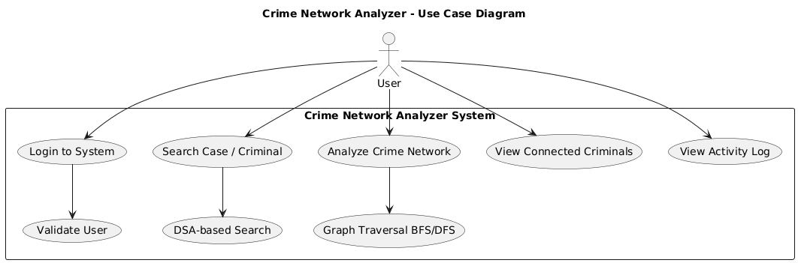

CLASS DIAGRAM
